Analysis of Collective Cell Migration in a Crowded Environment

1. Introduction
In this project, we explore how physical obstacles affect the way cells move together. We know from previous studies that cells can migrate collectively, moving like a fluid group when they have space. However, in a real biological environment, tissues are rarely empty, they are full of other structures that might block the way. The goal of this experiment is to simulate this "crowded" environment using the Cellular Potts Model (CPM). We want to answer a simple question: what happens to the flow of migrating cells when we place static objects in their path, and how does the number of these objects change the outcome?

2. Methods and Implementation
To run these experiments, we used the Artistoo framework. We set up a simulation grid that contains two different types of cells. The first type represents the migrating tissue (active cells), and the second type represents the obstacles.
Modeling the Obstacles: To model an obstacle in the CPM, we didn't need to introduce complicated external boundaries. Instead, we simply used the framework to create a second type of cell ("Kind 2") that behaves like a physical barrier. The main idea was to define a cell that is passive and rigid, unlike the active cells that are migrating.
To make sure these obstacles stay still and keep their round shape, we adjusted a few key parameters. First, we removed the ActivityConstraint (or set MAX_ACT to zero) for these cells, which stops them from trying to move or extend protrusions on their own. Second, to stop them from getting squashed when the active cells push against them, we gave them a much higher volume constraint (λ_{vol} = 500) than the comparing to the migrating cells (λ_{vol} = 30). Finally, we set the adhesion values (J) so that the migrating cells don't stick to the obstacles. This ensures the obstacles act just like solid objects that the cells have to slide past, rather than a surface they want to attach to.
Experimental Setup: We designed a simulation where the obstacles are placed in a regular grid pattern across the screen. We then filled the empty space between them with the active migrating cells. To test our hypothesis, we created two different scenarios by changing a variable in the code called spacing:
- Low Density: Obstacles are placed far apart (large spacing).
- High Density: Obstacles are placed very close together (small spacing).

3. Results
We ran the simulation for both scenarios and analyzed the visual behavior of the cells.
Scenario A: Low Obstacle Density
When observing the simulation with a low number of obstacles, the cells behave somewhat like water flowing around rocks in a river. You can clearly see that the group of red cells is able to separate slightly to pass around the black obstacles and then join back together on the other side. The movement is continuous, and even though they have to change their path slightly, the collective flow keeps going forward without much trouble.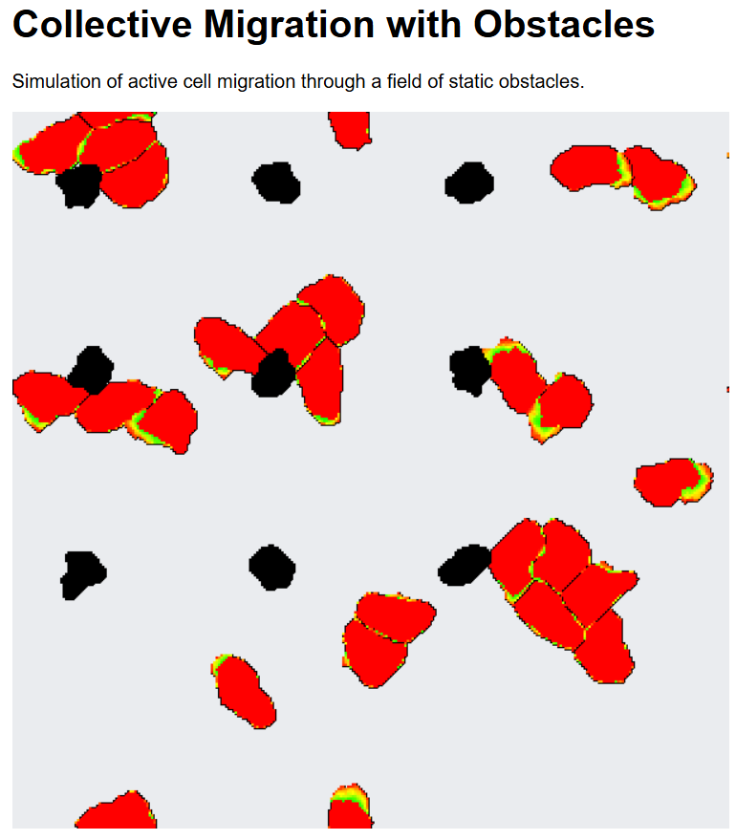Figure 1: Simulation with low obstacle density. The red cells can easily flow around the scattered black obstacles.
Scenario B: High Obstacle Density
However, the situation changes completely when we increase the number of obstacles by reducing the spacing between them. As the gaps between the black dots become smaller, the cells struggle to squeeze through. Visually, you can see groups of cells piling up behind the obstacles, pushing against each other but unable to move forward. This looks like a traffic jam, the cells get stuck in the narrow spaces, and eventually, the whole group stops moving almost entirely because there is simply no room for them to slide past one another.
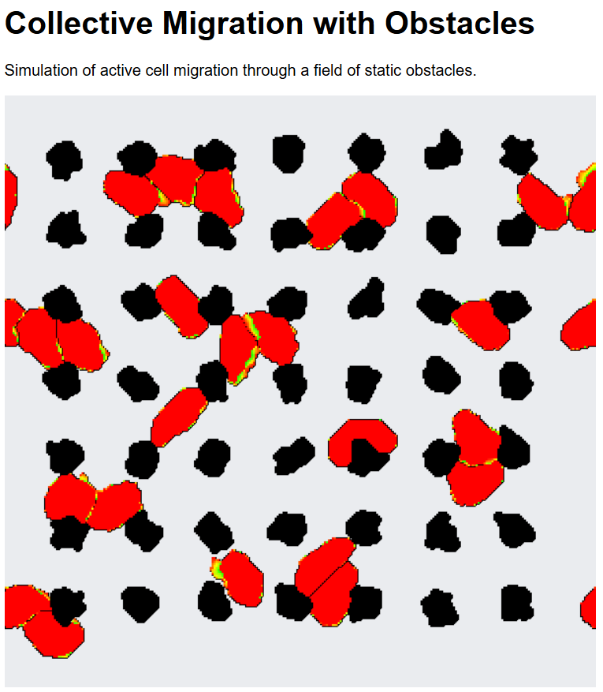Figure 2: Simulation with high obstacle density. The cells become "jammed" in the narrow gaps between obstacles, stopping the collective migration.

4. Discussion and Conclusion
Based on these results, we can conclude that obstacles act as a physical brake on collective cell migration. They change the behavior of the tissue in two main ways. First, they force the cells to take a longer, zig-zag path instead of a straight line, which naturally slows down their overall progress. Second, and most importantly, if the density of obstacles is too high, they cause a "jamming" effect. This means the environment becomes so crowded that the cells lose their fluid-like ability to flow and become stuck in a solid-like state where migration is no longer possible.
Limitations and Future Work
It is important to note that our obstacles were perfectly round and static. In a real biological tissue, obstacles might be irregular or might move slightly when pushed.
In this preliminary report, our analysis relied on visual inspection of the flow patterns and jamming transitions. To further validate these findings quantitatively in future work, we propose measuring the Mean Squared Displacement (MSD) of the cell centroids over time. We hypothesize that the MSD slope would decrease significantly as obstacle density increases, providing a numerical metric for the "braking" effect observed visually.

